**BACnet MSTP Adapter Operating Instructions**

**Ⅰ BACnet MSTP Adapter**

The schematic diagram of the Bacnet MSTP adapter is shown in Figure 1 below.

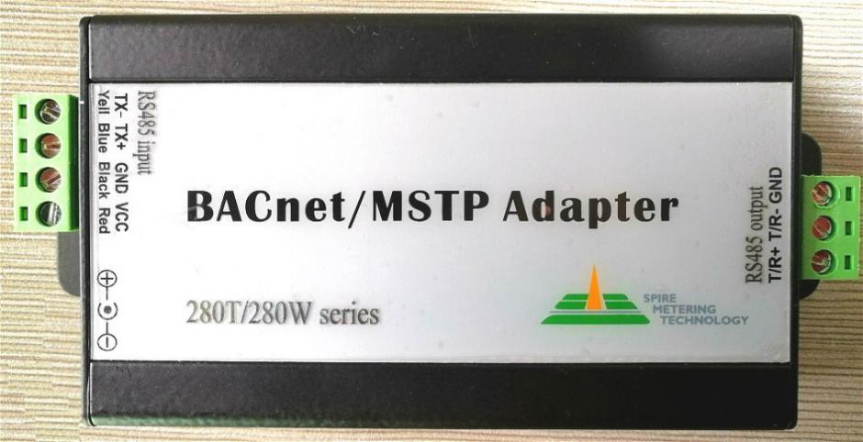

Figure 1 Schematic diagram of the Bacnet MSTP adapter

**II BACnet MSTP adapter structure diagram**

The structure diagram of BACnet MSTP adapter is shown in Figure 2 below.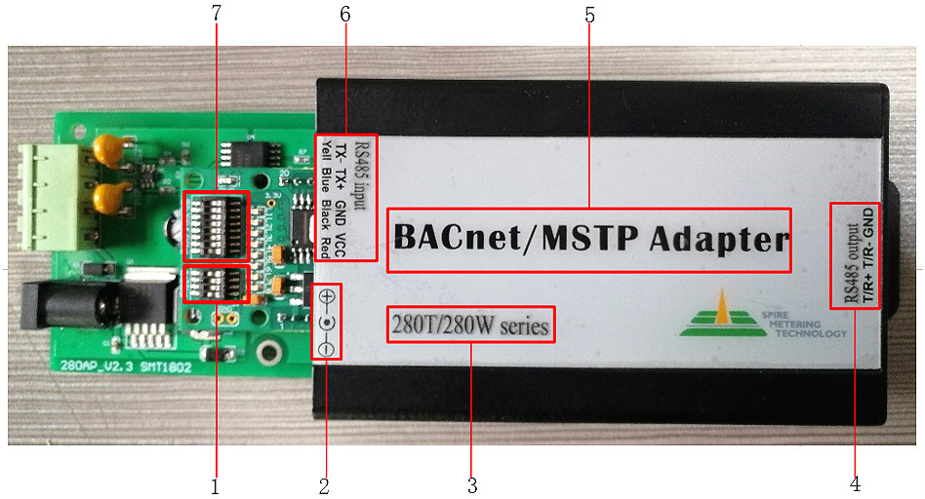

Figure 2 BACnet MSTP adapter structure diagram

The corresponding functions of the Numbers in the schematic diagram are as follows:

1：DIP switch for setting baud rate

2：DC24V / 1000mA power interface

3：Meter type label that the adapter can connect

4：RS485 output--Interface between adapter and converter

5：BACnet MSTP adapter name

6：RS485 output—Interface between adapter and meter

7：DIP switch for setting MAC address

1. **DIP switch for setting baud rate**

The DIP switch can set the baud rate of the RS485 output communication of the adapter，The position and direction of the adapter can be placed as shown in figure 2, or it can be determined by the position of the LCD.The adapter can be set to baud rates in four modes: 9600,19200,38400, and 76800.The baud rate Settings are shown in the following diagrams.

1. 9600 baud rate setting. B1, B2, B3, B4 DIP switch to the right, as shown in Figure 3 below，

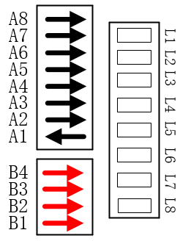

Figure 3 9600 baud rate

（2）9200 baud rate setting. B1 switch to the left, B2, B3, B4 switch to the right, as shown in Figure 4 below,

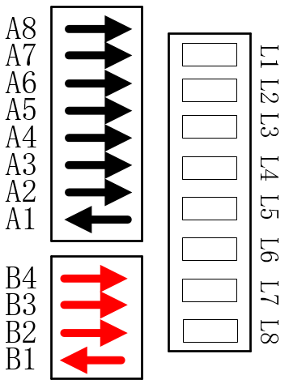

Figure 4 19200 baud rate

（3）38400 baud rate setting. B1 and B4 switch to the right, B2, B3 switch to the left, as shown in Figure 5 below

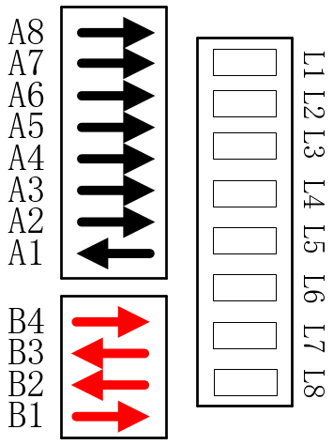

Figure 5 38400 baud rate

（4）76800 baud rate setting. There are three ways to set the baud rate of 76800, as shown in Figures 6 (a), 6 (b), and 6 (c) below.

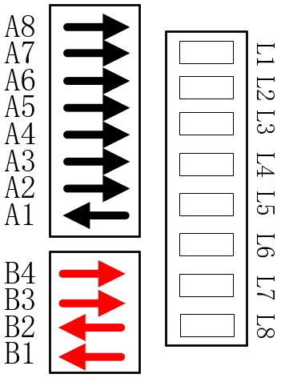 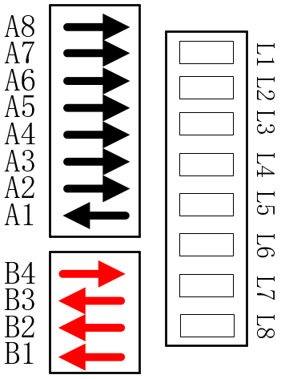 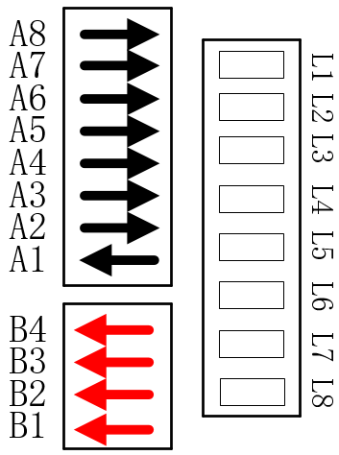

Figure 6(a) Figure 6(b) Figure 6(c)

1. **DC24V / 1000mA power interface**

The BACnet MSTP adapter is equipped with a DC 24V / 1000mA power adapter. The power adapter supplies power to the MSTP adapter.

1. **Meter type label that the adapter can connect**

According to this label, you can know the type of meter the adapter can connect to. This label indicates that the adapter can connect to the water meter of the 280W series and the heat meter of the 280T series.

1. **RS485 output--Interface between adapter and converter**

This interface is the connection between the BACnet MSTP adapter and the network converter. The adapter uploads the collected data to the server or PC platform for display through the network converter.

1. **BACnet MSTP adapter name**

The name of the adapter is BACnet MSTP, which is mainly used for the communication of MSTP protocol.

**6、RS485 output—Interface between adapter and meter**

The communication interface is connected to the meter through the RS485 bus, and uses the Mbus protocol to communicate with the meter. The schematic diagram of the connection between BACnet MSTP and the meter is shown in Figure 7 below.

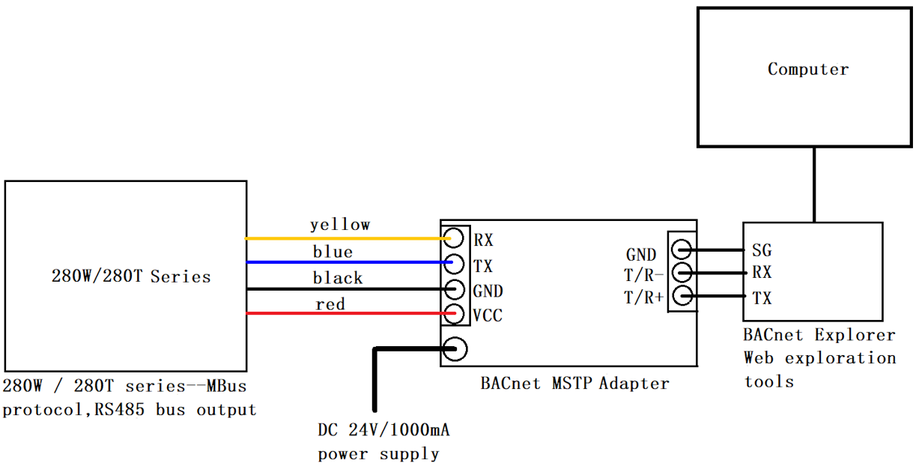

Figure 7 Schematic diagram of the connection between BACnet MSTP and the meter

**7、DIP switch for setting MAC address**

This row of DIP switches are binary DIP switches, which can set the MAC of the adapter. When setting the MAC address, the PCBA circuit board of the BACnet MSTP adapter needs to be placed as shown in Figure 2. DIP switch numbers are valid for A1-A7, number A8 is reserved, and the maximum MAC address can be set to 127. As shown in Figure 8 (a), set the MAC address to 1, and Figure 8 (b) set the MAC address to 127.

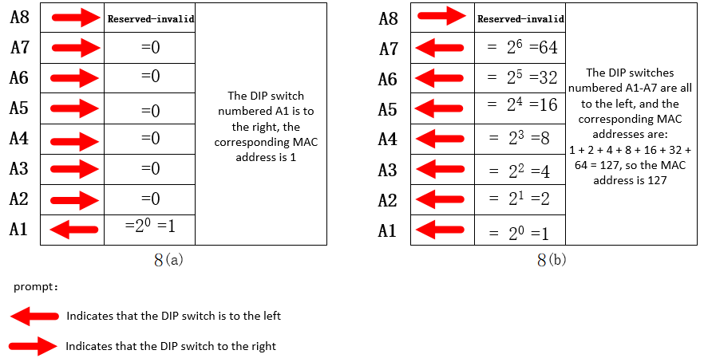

Note: The DIP switch cannot be set as shown in Figure 9 (a) and Figure 9 (b) below, otherwise you will not get the MAC address of the BACnet MSTP adapter.

